ASSIGNMENT -4

Retrieving Information from Tables.

Q1) write a select command that produces the order, number, amount and date for all rows in the order table

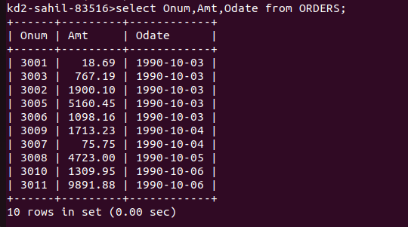

Q2) write a query that produces all rows from the customers table for which the sales persons number is 1001
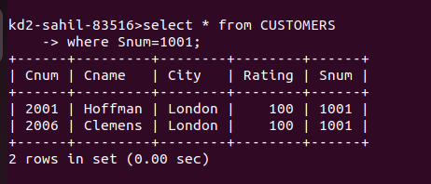

Q3) write a query that displays the salespeople table with the columns in the following order city, sname, snum, comm.

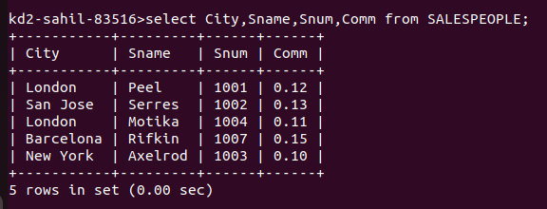

Q4) write a select command that produces the rating followed by the name of each customer in San Jose.

